**Graded Lab 04(b)**

**Outer Joins**

Use Bank Schema

|  |
| --- |
| **Task 1** |

Write a query to display the name of all the employees and transaction id of those whose transaction amount was greater than 150000 on Jan-1-2022.

SELECT e.name , t.transaction_ID

FROM Employee AS e

JOIN Transaction AS t

ON e.eid = t.eid

WHERE t.transaction_date = '2022-01-01'

AND t.transaction_amount > 150000;

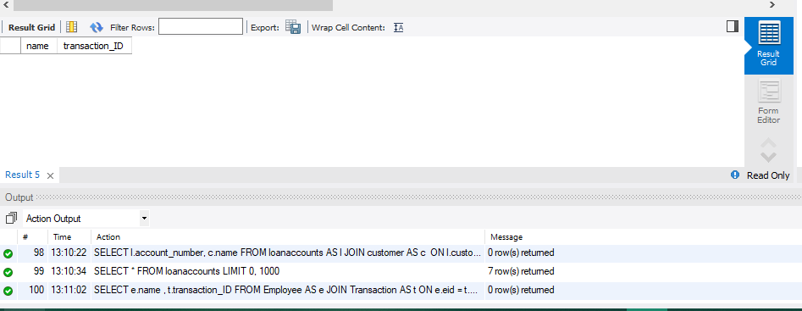

|  |
| --- |
| **Task 2** |

Write a query to display list of loan account numbers with names of customer whose current balacnce in loan account is in between 100,000 and 300,000

SELECT l.account_number, c.name

FROM loanaccounts AS l

JOIN customer AS c

ON l.customer_id = c.customer_id

WHERE l.current_credit BETWEEN 100000 AND 300000;

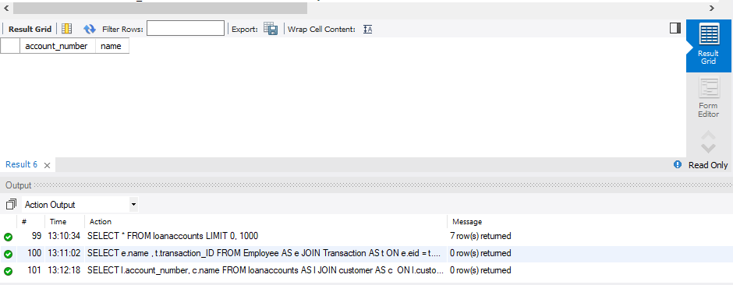

|  |
| --- |
| **Task 3** |

Write a query to display all the saving account number with their owner’s name.

SELECT s.Account_number , c.name

FROM SavingAccounts AS s

JOIN Customer AS c

ON s.customer_id = c.customer_id;

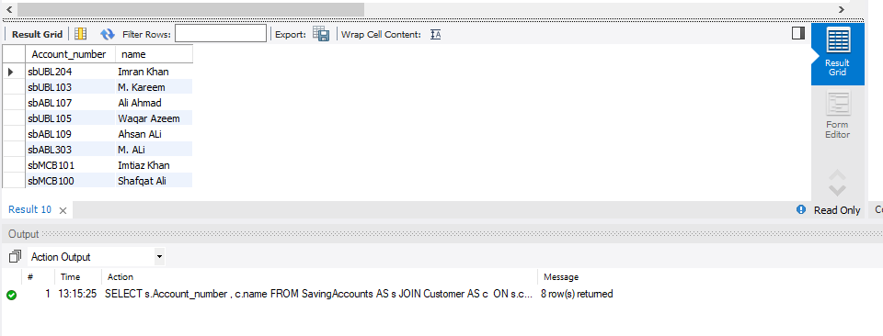

|  |
| --- |
| **Task 4** |

Write a query to display the all the transaction details with employee name whose transaction are greater than 1500000.

SELECT t.* , e.name

FROM Transaction AS t

JOIN Employee AS e

ON t.eid = e.eid

WHERE t.transaction_amount > 1500000;

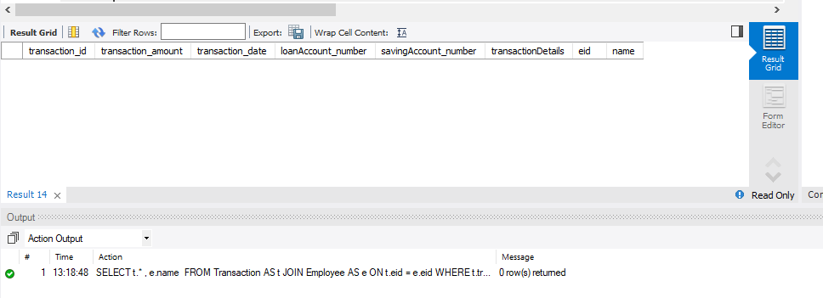

|  |
| --- |
| **Task 5** |

Display the name of all the bank with their branches location whose bank name start with ‘I’.

SELECT b.bank_name , br.branch_address AS Branch_location

FROM Bank AS b

JOIN Branch AS br

ON b.bank_id = br.bank_id

WHERE b.bank_name LIKE '%I';

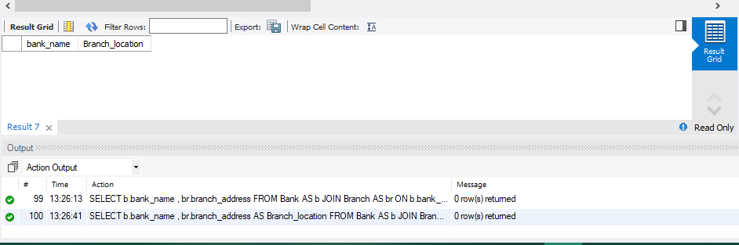

|  |
| --- |
| **Task 8** |

Write a query to display all the customer name with branch address having same amount (current balance in their account).

SELECT c.name,br.branch_address

FROM customer AS c

JOIN LoanAccounts AS l

ON c.customer_id = l.customer_id

JOIN Branch AS br

ON br.branch_id = l.branch_id

JOIN savingAccounts AS s

ON s.customer_id = c.customer_id;

|  |
| --- |
| **Task 9** |

Write a query to display number of employees in same branch of a bank.

SELECT b.bank_name, br.branch_address, COUNT(e.eid) AS num_employees

FROM bank AS b

JOIN branch br ON b.bank_id = br.bank_id

JOIN employee e ON br.branch_id = e.branch_id

GROUP BY b.bank_name, br.branch_address;

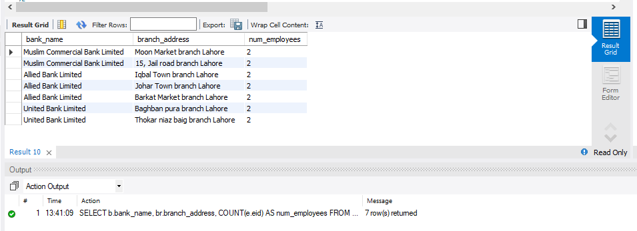

|  |
| --- |
| **Task 11** |

Write a query to display saving accounts which have transactions, saving accounts which have no transaction, and Transactions which are not from saving accounts.

SELECT sa.Account_number, COUNT(t.transaction_id) AS num_transactions

FROM savingaccounts sa

LEFT JOIN transaction AS t

ON sa.Account_number = t.savingAccount_number

GROUP BY sa.Account_number

HAVING num_transactions > 0;

SELECT sa.Account_number

FROM savingaccounts sa

LEFT JOIN transaction AS t

ON sa.Account_number = t.savingAccount_number

WHERE t.transaction_id IS NULL;

SELECT t.transaction_id, t.transaction_amount, t.transaction_date, t.transactionDetails, t.eid

FROM transaction AS t

LEFT JOIN savingaccounts sa

ON t.savingAccount_number = sa.Account_number

WHERE sa.Account_number IS NULL;

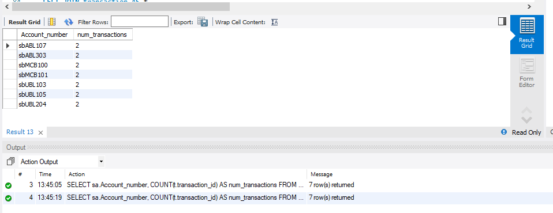

|  |
| --- |
| **Task 12** |

Write a query to display saving accounts which have no transaction, and Transactions which are not from saving accounts.

SELECT sa.Account_number

FROM savingaccounts sa

LEFT JOIN transaction AS t ON sa.Account_number = t.savingAccount_number

WHERE t.transaction_id IS NULL;

SELECT t.transaction_id, t.transaction_amount, t.transaction_date, t.transactionDetails, t.eid

FROM transaction AS t

LEFT JOIN savingaccounts sa ON t.savingAccount_number = sa.Account_number

WHERE sa.Account_number IS NULL;

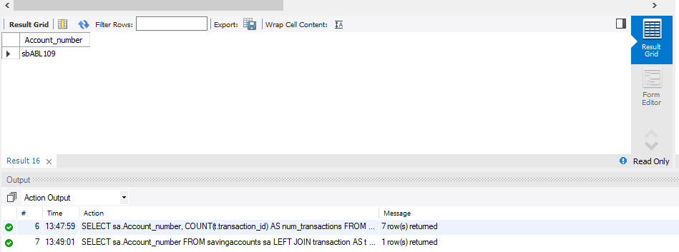

|  |
| --- |
| **Task 13** |

Write a query to display a list of all the customers and all the loan accounts( Without using inner join).

SELECT *

FROM customer, loanaccounts;

